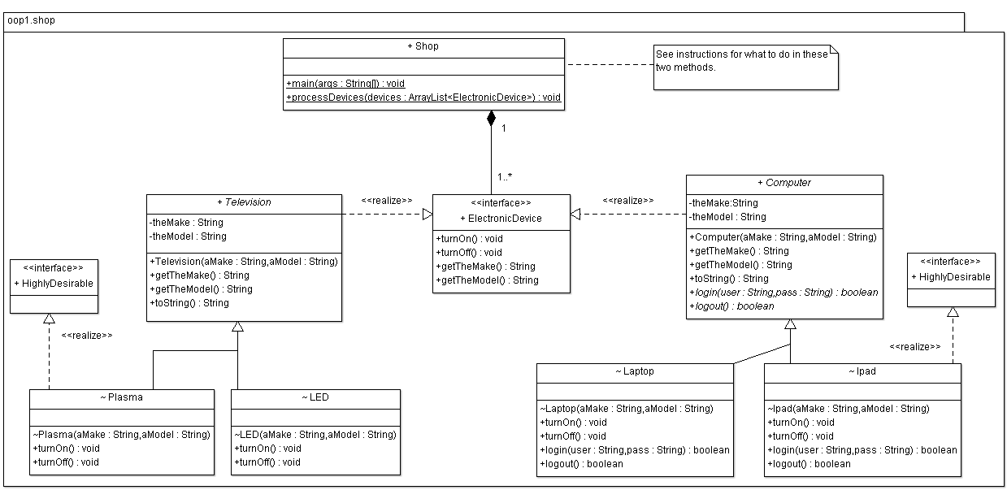

**Shop**

*main*() method:

* declare an array list named “devices” which can contain *ElectronicDevice* objects only.
* declare and initialise an electronic device reference that refers to a *Plasma* television object; the maker is “Sony” and the model is “P300”; add it to the array list.
* declare and initialise an electronic device reference that refers to a *Laptop* computer; the maker is “Dell” and the model is “Inspiron”; add it to the array list.
* invoke *the processDevices*() method, passing it the array list.

*processDevices*() method:

* for each electronic device in the array list do the following:
  + output the electronic devices’ details to the screen with a *System.out.print* command (see sample output).
  + if the electronic device is considered *HighlyDesirable* then output this fact (again, see sample output).

**ElectronicDevice** - As per the UML diagram.

**HighlyDesirable** - This is a tagging interface that is used for its type information only.

**Television** - As per the UML diagram.

**Plasma/LED** - The *turnOn()* and *turnOff()* methods are simple tracer methods e.g. for Plasma, just

*System.out.println(“Plasma::turnOn()”);* and *System.out.println(“Plasma::turnOff()”);* respectively.

**Computer** - As per the UML diagram.

**Laptop/Ipad** - The *turnOn()* and *turnOff()* methods are simple tracer methods e.g. for Laptop, just

*System.out.println(“Laptop::turnOn()”); and System.out.println(“Laptop::turnOff()”);* respectively.

- The *login(String,String)* and *logout()* methods are simple tracer methods e.g. for Laptop, just

*System.out.println(“Laptop::login()”); and System.out.println(“Laptop::logout()”);* respectively. Both of these methods

return *true.* Note that the arguments to *login(String,String)* are not used by the method.

**Sample Output**

Sony P300 - Highly Desirable Item

Dell Inspiron

**Notes:**

There are **5 java files** to be zipped when you are finished:

* ElectronicDevice.java
* HighlyDesirable.java
* The Television hierarchy goes into Television.java (*Television*, *Plasma* and *LED* classes)
* The Computer hierarchy goes into Computer.java (*Computer*, *Laptop* and *Ipad* classes)
* Shop.java

